2.4 Limitation and Improvement

2.4.1 Limitation

For the model in 2.2 as the following form, we should check the regression assumption that error terms are independent with each other and if the model is adequate.



2.4.2 Remedies

We fit additive models in the following forms



|  |  |
| --- | --- |
| Beta0 | intercept for detectability of the stimulus |
| Beta(i) | difference in detectability of the stimulus between i level of SPL and reference level of SPL |
| Alpha(j) | difference in detectability of the stimulus between j level of carrier and reference level carrier |
| Gamma(I,j) | difference in detectability of the stimulus between the interaction of j level of carrier and i level of SPL and the reference level of interaction |

Table Parameters for the Additive Model

2.4.3 Conclusions

|  |  |  |
| --- | --- | --- |
| Model | Deviance | d.f. |
| Null | 834.74 | 671 |
| *One Factor Model* |  |  |
| SPL | 707.45 | 668 |
| Carrier | 782.92 | 664 |
| *Two Factor Model* |  |  |
| SPL+Carrier | 644.7 | 661 |
| SPL+Carrier+ SPL*Carrier | 559.21 | 640 |

Table Deviance for the Whole Model

The additive model has a deviance of 190.04 at only 10 degrees of freedom. So the model provides a good description of the data. The two factor model with interaction has a deviance of 275.53 at only 31 degrees of freedom. So the interaction between SPL and carrier has a significant effect on the model and thus the model provides a good description of the data.

Our conclusion is that the model with two factors and interaction is the most accurate and adequate model.

2.4.2 Assumptions Checking

What are the limitations of your methods? Pay special attention to the independence assumption. Any remedies?

* + - 1. One Factor Model

1. Model

We consider the following two one factor regression models:



1. Arguments and Parameters:

EFRs: representing the detectability of the stimulus

SPL: controlled stimulus pressure level that was presented to the participant, which isa categorical data with 4 levels

Carrier: speech sounds, which is a categorical data with 8 levels

Beta0: intercept for detectability of the stimulus

Beta(i): difference in detectability of the stimulus between i level of SPL and reference level of SPL

Beta(j): difference in detectability of the stimulus between j level of carrier and reference level of carrier

1. Analysis

For model (1)

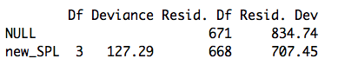

Table Deviance of One Factor Model (1)

Null model has a deviance of 834.74 on 671 degrees of freedom, the p-value is nearly asymptotic to 0, which doesn’t pass the goodness-of-test, so we reject the null hypothesis that all detectability is the same with the change of SPL.

Introducing SPL variable leads to substantial reduction of 127.29 deviance at only 3 degrees of freedom. So the variable of SPL has significant effect on the detectability of the stimulus.

For model (2)

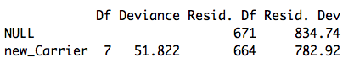

Table Deviance of One Factor Model (2)

Also, null model doesn’t pass the goodness-of-test. Introducing Carrier variable leads to substantial reduction of 127.29 deviance at only 7 degrees of freedom. So the variable of Carrier has significant effect on the detectability of the stimulus.

* + - 1. Two Factor Model

1. Additive Model



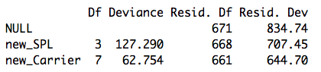

Table Deviance of Two Factor Model

Beta0: intercept for detectability of the stimulus

Beta(i): difference in detectability of the stimulus between i level of SPL and reference level of SPL

Alpha(j): difference in detectability of the stimulus between j level of carrier and reference level carrier

The additive model has a deviance of 190.04 at only 10 degrees of freedom. So the model provides a good description of the data.

1. Two Factor Model with Interaction



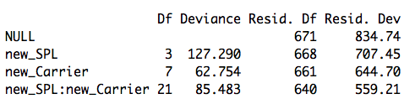

Table Deviance of Two Factor Model with Interaction

The two factor model with interaction has a deviance of 275.53 at only 31 degrees of freedom. So the interaction between SPL and carrier has a significant effect on the model and thus the model provides a good description of the data.

* + - 1. Conclusions

Based on the analysis above, we can get the following table.

|  |  |  |
| --- | --- | --- |
| Model | Deviance | d.f. |
| Null | 834.74 | 671 |
| *One Factor Model* |  |  |
| SPL | 707.45 | 668 |
| Carrier | 782.92 | 664 |
| *Two Factor Model* |  |  |
| SPL+Carrier | 644.7 | 661 |
| SPL+Carrier+ SPL*Carrier | 559.21 | 640 |

Table Deviance for the Whole Model

Our conclusion is that the model with two factors and interaction is the most accurate model so that accuracy differs both between carriers and frequency groups. What’s more, accuracy differs between the interaction of carriers and frequency groups, too.